Given the root of a binary search tree (BST) with duplicates, return *all the* [*mode(s)*](https://en.wikipedia.org/wiki/Mode_(statistics)) *(i.e., the most frequently occurred element) in it*.

If the tree has more than one mode, return them in **any order**.

Assume a BST is defined as follows:

* The left subtree of a node contains only nodes with keys **less than or equal to** the node's key.
* The right subtree of a node contains only nodes with keys **greater than or equal to** the node's key.
* Both the left and right subtrees must also be binary search trees.

**Example 1:**

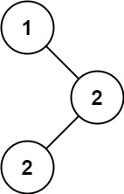

Input: root = [1,null,2,2]  
Output: [2]

**Example 2:**

Input: root = [0]  
Output: [0]

**Constraints:**

* The number of nodes in the tree is in the range [1, 104].
* -105 <= Node.val <= 105

**Follow up:** Could you do that without using any extra space? (Assume that the implicit stack space incurred due to recursion does not count).